# **Task 1**

Student Name: Shreyas Bharadwaj Nidaghatta Ravi

Student ID: 11645440

Email: [shreyasnr6666@gmail.com](mailto:shreyasnr6666@gmail.com)

Lecture Name: Recep Ulusoy

**Screenshots:**

Menu display:

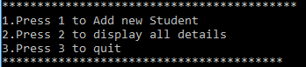

Choice entered from the menu is 1:

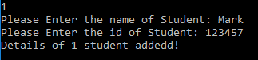

Choice entered from the menu is 1 and invalid id has been entered:

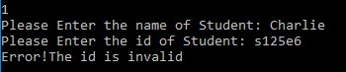

Choice entered from the menu is 1 and invalid id has been entered:

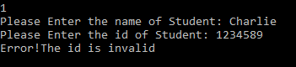

Choice entered from the menu is 2:

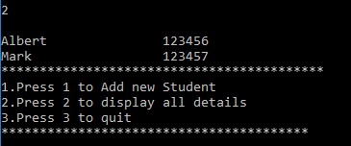

Choice entered from the menu is 3:



**Logic explanation:**

The student class has been created which will have the student details. We have used our logic for two function that will check whether the id already exists in the file and also check that the id entered is valid or not.

For checking that the id already exists in the text file, we have read data from the text file using BufferedReader class. Using while loop, we have read all the lines from the text file(students.txt).

For checking that the id entered is valid, we have used the for loop that will match each of the character entered for the student ID. Before using for loop we will check the length of the id. If the length is equal to 6 then only for loop will be implemented. We will update Boolean variable accordingly.

The other class used is TestStudent which will first display the menu. The user will input the value from the menu. Before that all the data will be read from the text file (staff.txt). The file will be read with the same logic as explained above. Then menu will be displayed each time unless user will not select quit option. For this, we have used while loop. Inside while loop we have used if-else statements which will check the input selected.